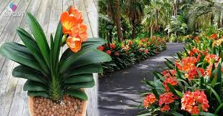

Scientific name: Clivia Miniata (lan quân tử )

LIGHT:

Indoors near a window that gets morning sunlight, or in a shady spot on your veranda, deck or courtyard.

.

WATERING:

Keep potting mix moist in spring and summer. Over-watering will cause root rot so allow excess water to drain away. Don’t use a pot saucer but put your pots on feet instead. Terracotta pots are best as they absorb excess moisture. Reduce watering in autumn and stop watering in winter. Resume watering when flower stalks appear at end of winter. Don’t mist spray the leaves.

SOIL:

Before you re-pot your clivia offset, choose a good quality potting mix with a little peat moss or sand in it. Loosen your soil to make sure that it is well-draining which can help you avoid root rot.

FERTILIZING:

Apply liquid fertiliser every two weeks from when flower stalks are half developed and continue until autumn.

Feed immediately after flowering with a general purpose fertiliser plus top ups until mid summer.

Temperature and Humidity:

They enjoy a warm spot but need about two months of cool temperatures (about 10C) in winter to ensure good flowering.